Name: Class:

7th Grade Math Summer Packet/6th Grade Math Retention Assessment

1. Each of the seven CAS basketball players shoot 30 free throws during a practice session. The numbers of baskets they make are listed below. What is the median number of baskets made?
Number of baskets: 22, 23, 12, 18, 22, 20, 16

A. 18 B. 15 C. 20 D. 12

2. Ms. Maddock mixes 4 cups of blue paint with 3 ½ cups of red paint to make Perfect Purple Paint. How many cups of red paint does she need if she uses 8 cups of blue Paint?

Paint Color | Cups | Cups
Red | 3 ½ | ?
Blue | 4 | 8

A. 4 cups B. 7 cups C. 2 cups D. 1 cup

3. Mr. Sullivan gets 6 apples for 30 oranges. What is the unit rate in $\frac{apples}{oranges}$ ?
- $\frac{1 apple}{0.2 oranges}$
- $\frac{5 apples}{1 orange}$
- $\frac{1 apple}{5 oranges}$
- $\frac{0.2 apple}{1 orange}$

4. Identify the greatest common factor (GCF) of 48 and 24.

- 4 B. 6 C. 12 D. 24

5. What inequality is represented by this graph?
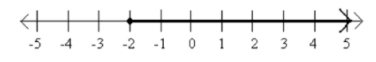

A. x < -2 B. x > -2 C. x ≤ -2 D. x ≥ -2

6. Put the following in increasing order: 0.5, 0.05, 0.49

A. 0.5, 0.05, 0.49 B. 0. 49, 0.05, 0.5 C. 0.05, 0.5, 0.49 D. 0.05, 0.49, 0.5

7. What is the solution to the equation: 3y = $\frac{9}{10}$

A. y = $\frac{3}{10}$ B. y = $\frac{27}{10}$ C. y = $\frac{1}{3}$ D. y =$\frac{10}{ 9}$

8. Simplify: 12 x 0.6

A. 0.72 B. 7.2 C. 72 D. 720

9. Simplify: 2 ÷ 5

A. 2.5 B. .25 C. 4.0 D. 0.4

10. Add and reduce to lowest terms: $\frac{2}{8}$ + $\frac{1}{2}$

A. $\frac{3}{4}$ B. $\frac{1}{8}$ C. $\frac{3}{10}$ D. $\frac{3}{8}$

11. Simplify: $\frac{2}{3}$ x $\frac{3}{4}$

A. $\frac{5}{7}$ B. $\frac{6}{12}$ C. $\frac{8}{9}$ D. $\frac{1}{2}$

12. Simplify: $\frac{3}{10}$÷ $\frac{1}{3}$

A. $\frac{3}{30}$ B. 1 C. $\frac{9}{10}$ D. $\frac{3}{10}$

13. Write as a decimal: $\frac{3}{100}$

A. 0.3 B. 3.0 C. 0.03 D. 0.003

14. Ms. Grimm has a 20% off coupon. The original price of the shirt she wants to buy is $30. How much money did she save with the coupon?

A. $0.20 B. $1.50 C. $2.40 D. $6

15. Name the coordinate that represents the ordered pair: (-3, 2)

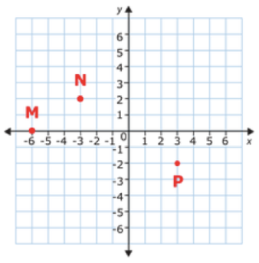

A. M B. N C. P D. None of these

